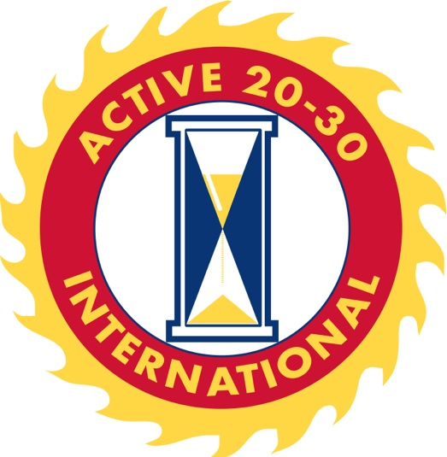

The Carson Valley Active 20-30 Club #85 is pleased to announce this year’s 114th Annual “Carson Valley Days Festival” will be held June 6th - June 9th, 2024! We’ve selected this year’s parade theme to be “Music is Carson Valley- MCV.

Come join us and make this year’s Carson Valley Days Festival the best yet!

- Carnival Rides for all Ages at Lampe Park: Thursday, Friday, Saturday, and Sunday
- Free Live Music at Lampe Park: Friday Night and Saturday
- Parade: Down Town Minden to Gardnerville on Saturday Morning at 9:00 am
- Craft Fair Vendors, Food Vendors, Face Painting, Children’s Games, Horseshoe Tournament, Basketball Tournament and Corn Hole Tournament at Lampe Park: Thursday through Sunday
- Raffle Drawing 11am at Lampe Park: Sunday

The Carson Valley Active 20-30 Club #85 has participated in this event since the 1930’s. For the last 60+ years, we’ve had the privilege of hosting this event, while continuing its legacy. As our club gears up for another exciting year, we ask you for HELP!

Hosting this wonderful event isn’t easy, nor does it come at a cheap cost. Each year our club seeks ways to cover the nearly $40,000.00 in expenses required to bring this event to life. Because we are a 501c (4), we ask for your assistance this year in covering costs so we may focus more of our funds towards donating to charities within our community throughout the year.

How can you help?

We have opportunities for both individuals and companies. By becoming a Sponsor of Carson Valley Days, you not only help give back to your community’s children in need, but also promote your business. You may choose to purchase a vending spot, sponsor an activity, volunteer your time, or give monetarily. You will receive fantastic exposure for your business throughout the weekend. We will post your banners or signs and announce your involvement via the Main Stage, letting all participants know who helped bring this all together.

The Carson Valley Active 20-30 Club #85 donates the proceeds to many local charities and programs within the Carson Valley. These include:

Douglas County Youth Athletics, Children's Food Program, Douglas County Youth 4-H, Project Santa Claus Kids Christmas Present Program, Austin’s House, Douglas County Boys and Girls Club, Gardnerville Easter Egg Hunt, Douglas County Center for Hope and Healing, Douglas County Future Farmers of America, Douglas County Community Center, and Many More!

All sponsorships and contributions are tax deductible. Tax ID# 72-1558200

If you have any questions or would like further details check us out at www.carsonvalley2030.com or contact a local club member.

Thank you for your support,

Aaron Meeden
Carson Valley Days Chairman
Sponsorship Levels

Grand Presenter Sponsor: $8,000 (limited to two sponsors)
The Carson Valley Days Grand Presenter sponsorship is a great opportunity for your company to get involved and gain exposure with this time-honored successful event. Sponsorship benefits are:
- EXCLUSIVITY: limited to Two sponsors
- Thirty Carnival Bracelets for Wednesday evening Sponsor Night at Lampe Park
- Company Logo on the sleeve of the Carson Valley Days T-Shirt, along with complimentary T-shirts
- All perks earned by Legacy Sponsors
- VIP experience provided on Sunday of Carson Valley Days:
  - Twenty Carnival Tickets for Sunday
  - Carnival Tickets are good from open to close on Sunday
  - A private space for a BBQ put on by your Carson Valley Active 20-30 Club for Twenty people
  - Exclusive musical performance
  - Discounted price from the Carson Valley Beer Booth for those 21+ on Sunday

Legacy Sponsor: $5,000 (limited to three sponsors)
- EXCLUSIVITY: limited to Three sponsors
- Thirty Carnival Bracelets for Wednesday evening Sponsor Night at Lampe Park
- Ten Carnival Bracelets for Sunday of Carson Valley Days
- Vendor space at Lampe Park (Limited to Non-Food Vendor Spaces)
- Carson Valley Days Parade Entry
- Sign advertisements around Lampe Park and on the Music & Activities Stage
- Company logo positioned at the top of the back of the Carson Valley Days T-shirt, along with complimentary T-shirts
- Legacy Sponsor plaque to proudly display at your place of business
- Recognition in all media advertisement (Posters, flyers, newspapers, etc.), including logo on our parade route on Saturday.

Jobs Peak Sponsor: $3,000 Dollars

- Fifteen Carnival Bracelets for Wednesday evening Sponsor Night at Lampe park
- Five Carnival Bracelets for Sunday of Carson Valley Days
- Vendor space at Lampe Park (Limited to Non-Food Vendor Spaces)
- Carson Valley Days Parade Entry
- Sign advertisements around Lampe Park
- Company logo on the Carson Valley Days T-shirt, along with complimentary T-shirts
- Plaque to proudly display at your place of business
- Recognition in most media advertisement (Posters, flyers, newspapers, etc.), including logo on our parade route on Saturday

Pinenut Sponsor: $1,000 Dollars

- Ten Carnival Bracelets for Wednesday evening Sponsor Night at Lampe Park
- Parade entry for the Carson Valley Days parade
- Sign advertisements in Lampe Park
- Company name on the Carson Valley Days T-shirt, along with complimentary T-shirts
- Certificate to proudly display at your place of business
- Recognition in some media advertisement

Carson River Sponsor: $500 Dollars

- Two Carnival Bracelets for Wednesday evening sponsor night at Lampe Park
- One sign advertisement at selected areas in Lampe Park (sign provided by sponsor)
- Recognition in some media advertisement

